**ASSIGNMENT -3**

**REGRESSION**

|  |  |
| --- | --- |
| Assignment Date | 29 September 2022 |
| Student Name | Manjunathan V |
| Student Roll Number | 727719EUCS080 |
| Maximum Marks | 2 Marks |

**Question-1:**

Download the dataset: Dataset

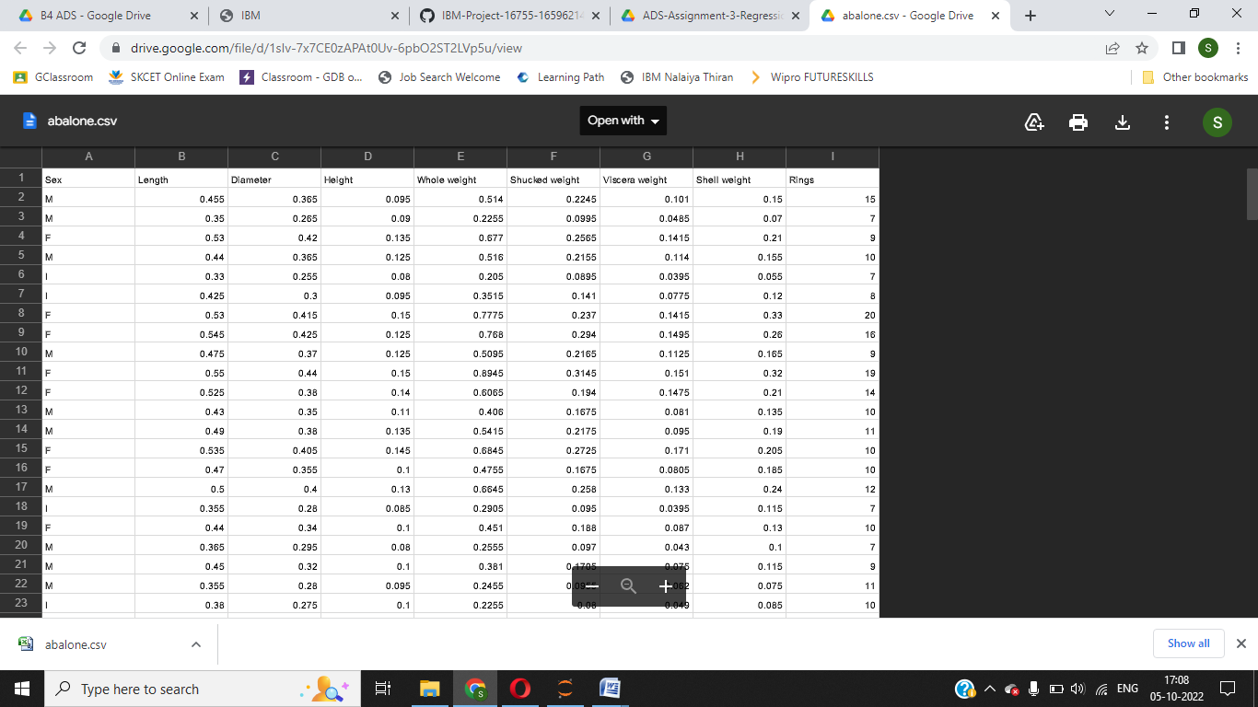

**Question-2:**

Load the dataset.

**Solution:**

import pandas as pd

import numpy as np

import matplotlib.pyplot as plt

import seaborn as sns

df = pd.read_csv("C://Users//Mohana Sowdesh//Downloads//abalone.csv")

df.head()

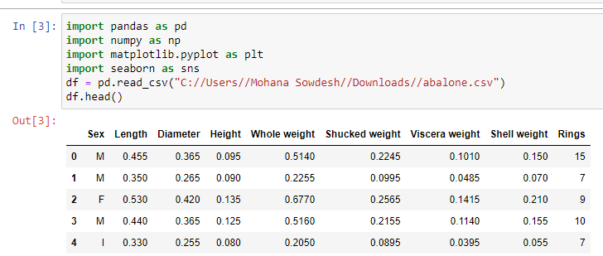

**Question-3:**

Perform Below Visualizations.

∙ Univariate Analysis

**Solution:**

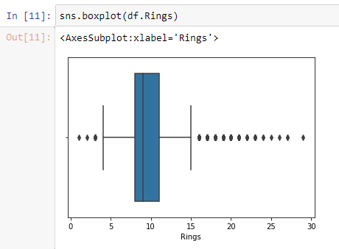

∙ Bi-Variate Analysis

**Solution:**

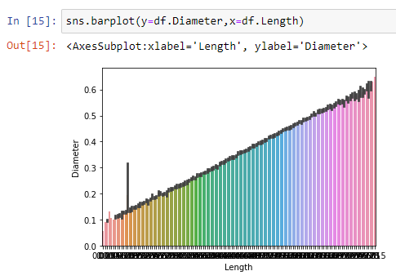

∙ Multi-Variate Analysis

**Solution:**

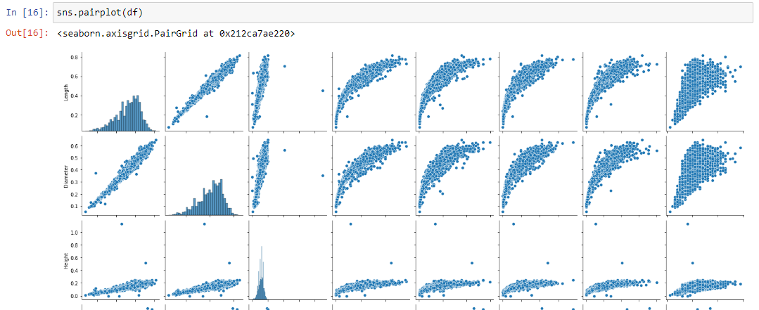

**Question-4:**

Perform descriptive statistics on the dataset.

**Solution:**

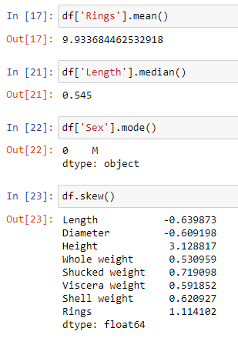

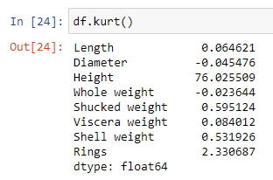

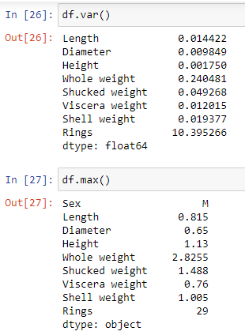

**Question-5:**

Handle the Missing values.

**Solution:**

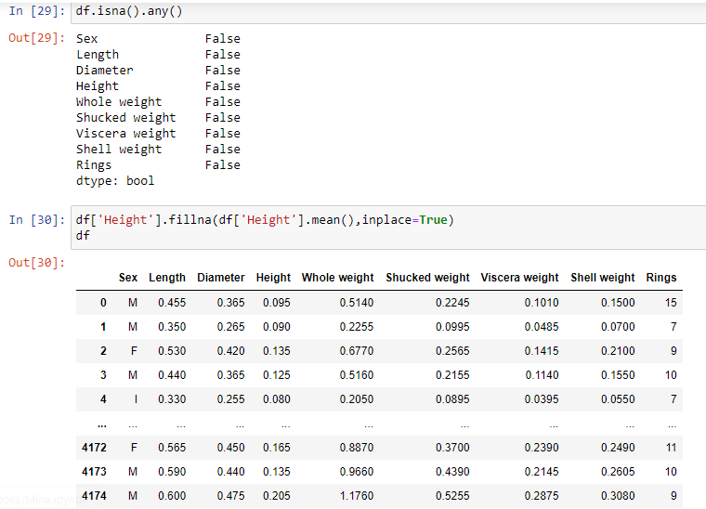

**Question-6:**

Find the outliers and replace the outliers

**Solution:**

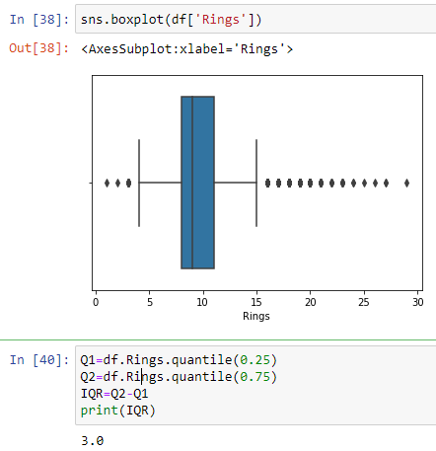

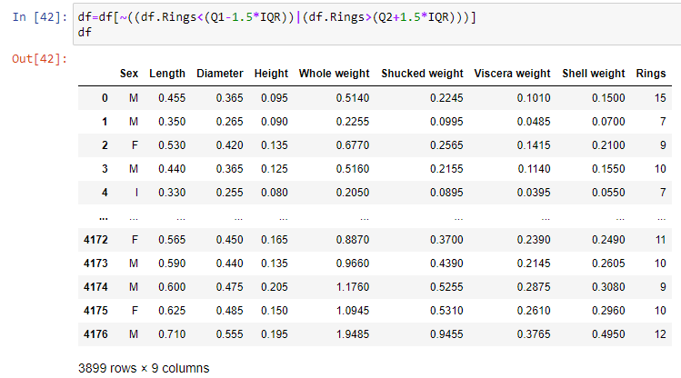

**Question-7:**

Check for Categorical columns and perform encoding.

**Solution:**

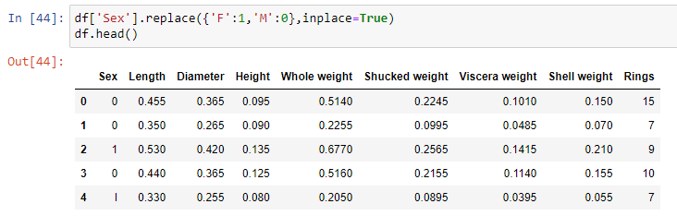

**Question-8:**

Split the data into dependent and independent variables.

**Solution:**

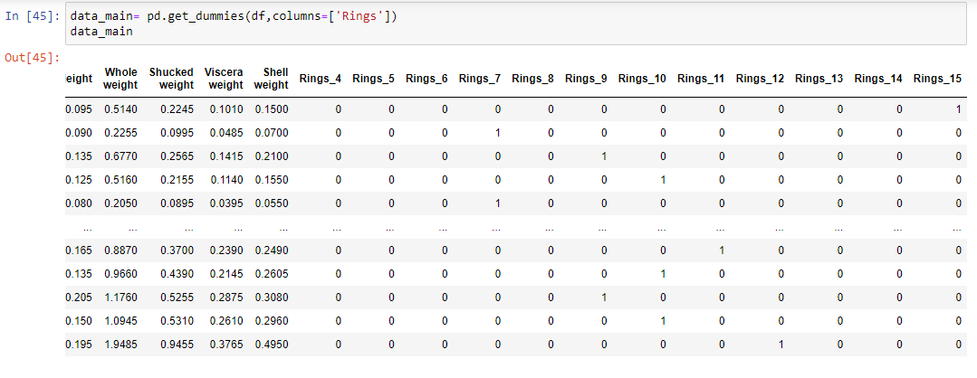

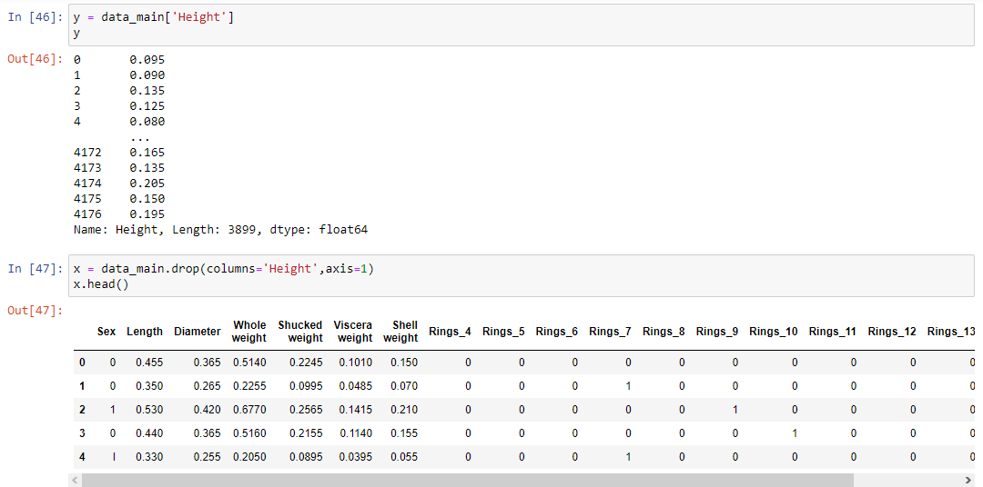

**Question-9:**

Scale the independent variables

**Solution:**

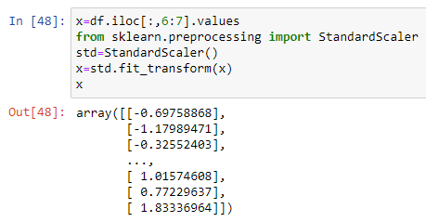

**Question-10:**

Split the data into training and testing

**Solution:**

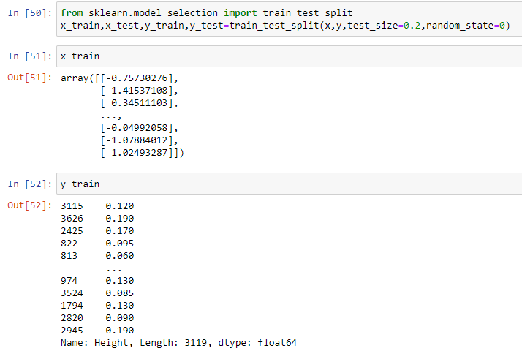

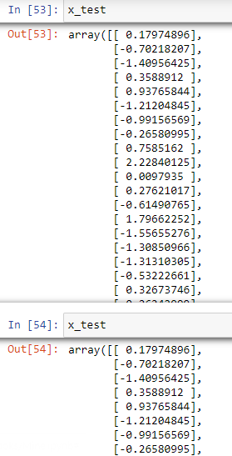

**Question-11:**

Build the Model

**Solution:**

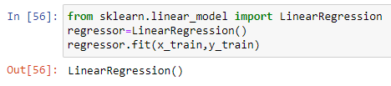

**Question-12:**

Train the Model

**Solution:**

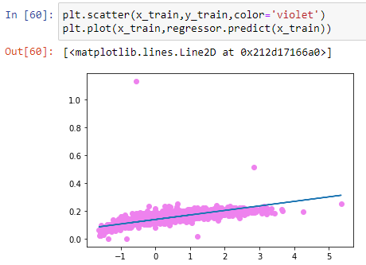

**Question-13:**

Test the Model

**Solution:**

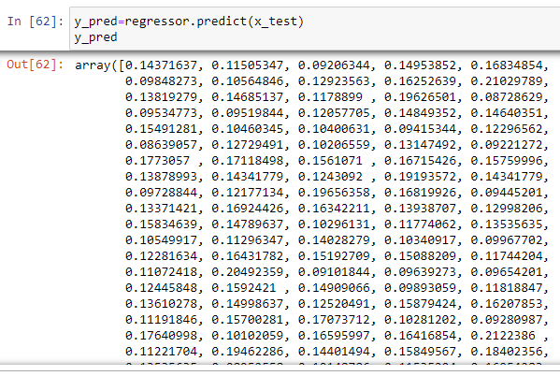

**Question-14:**

Measure the performance using Metrics.

**Solution:**

